Selection Parameters Model Analysis

# *The acronym "PEO" is used herein for illustrative purposes only and has been changed from the original designation to preserve anonymity and confidentiality. This representation is not intended to reflect any specific real-world work group, organization, or role. Any resemblance to actual job titles, group names, or organizational structures is purely coincidental and unintentional.*

This testing model is a visual representation of selection systems using real data. The intent is to show the spread of overtime selection on a workforce based on varying selection parameters. It is not a reflection of complete real-world accuracy due to the following:

* PEO volunteer choice cannot be perfectly replicated or projected.
* Trades are not accounted in this model.
* Exemptions are not accounted in this model.
* Events do not have Roll Call times and are assumed to not overlap.

# Testing System Parameters:

* 80 Unnamed PEO’s sorted by Seniority.
* 281 Events
  + Staffing needs for each event reflect the 281 Special Events that occurred in 2022.
* Random Volunteer choice per/PEO, per/Event, using a 20% volunteer rate.

# Seniority Model Description:

* Volunteers selected first, selected by Seniority high to low.
* Mandatory selection if needed, selected by Reverse Seniority.

# Skipping-Mandatory Only Model Description:

* Volunteers selected first, selected by Seniority high to low. *(Same as Seniority Model)*
* Mandatory selection if needed, selected by Reverse Seniority.
  + Once mandatorily selected, a PEO is sent to the bottom of the mandatory selection list.

# Skipping-All Model Description:

* Volunteers selected first, selected by Seniority high to low.
  + Once volunteer selected, a PEO is sent to the bottom of the volunteer selection list.
* Mandatory selection if needed, selected by Reverse Seniority.
  + Once mandatorily selected, a PEO is sent to the bottom of the mandatory selection list.

# PEO Staffing Needs over 281 Events:

In 2022, the average PEO staffing needed per event was 8.34 positions. Events with large staffing needs became most frequent later in the year. Seahawks, and Husky Football Events made up most large events, while Kraken and Mariners games made up the most frequent events and with a smaller footprint.

With our estimated 20% volunteer rate and 80 PEOs, we should average 16 volunteers per event. Most events will be staffed through volunteers.

# Selection System Results:

This graph below shows the spread of total events selected for over a 281-event period.

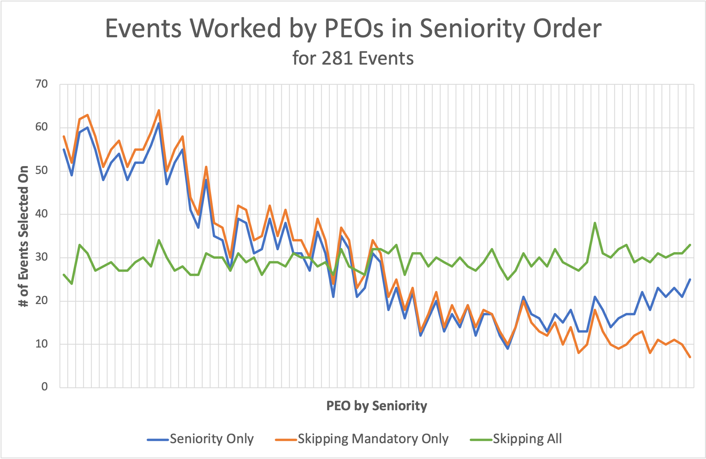

|  |  |  |
| --- | --- | --- |
| **Average Events Selected** | **Top 40 PEOs** | **Bottom 40 PEOs** |
| **Seniority** | *41.1* | *17.5* |
| **Skipping Mandatory Only** | *44.1* | *14.6* |
| **Skipping All** | *28.7* | *29.9* |

Takeaways:

1. The Seniority Only and Skipping Mandatory Only systems are nearly identically for the majority of PEO’s. This is due to most events staffed fully using only volunteers.
2. The Seniority and Skipping Mandatory systems give PEOs with high seniority more overtime opportunities.
3. The Skipping All system has the most balanced effect, giving PEOs even distribution of events regardless of seniority.

The chart below shows the overall satisfaction score for each PEO.

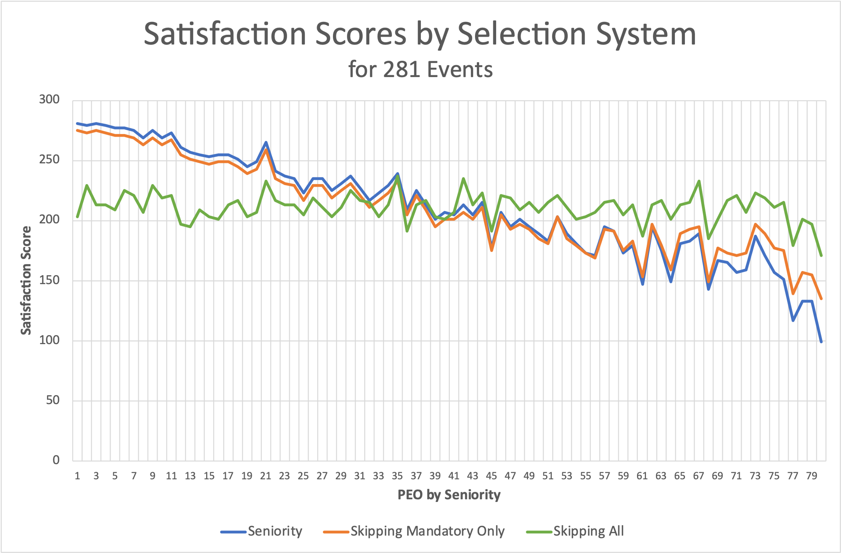

Scores are calculated by taking the PEO’s desired result and returning the outcome. If the result was desired, the scores goes up by 1, if it is not desired, the scores goes down by 1. Max score is 281. Minimum score is -281.

|  |  |  |
| --- | --- | --- |
| **Average Satisfaction Score** | **Top 40 PEOs** | **Bottom 40 PEOs** |
| **Seniority** | *246.8* | *175.0* |
| **Skipping Mandatory Only** | *240.9* | *180.8* |
| **Skipping All** | *212.4* | *209.4* |

Takeaways:

1. The Seniority Only and Skipping Mandatory Only systems are identically for the majority of PEO’s. This is due to most events staffed fully using only volunteers.
2. The Seniority and Skipping Mandatory systems show PEOs with higher seniority are more satisfied.
3. The Skipping All system more evenly disperses the satisfaction scores to all PEOs.

# “Skipping All” System Visualized:

### Step 1:

Sort List

|  |  |
| --- | --- |
| **PRE-Event #1 Volunteer**  **and Non-Volunteer List** | |
| **Volunteer List (V)** | **Mandatory List (M)** |
| PEO 1  PEO 2  PEO 3  PEO 4  PEO 5  … | PEO 80  PEO 79  PEO 78  PEO 77  PEO 76  … |

*PEO’s are all on both lists.

### Step 2:

Event Details

Event #: 1

PEOs Needed: 5

### Step 3:

PEO Volunteer Requests

|  |  |
| --- | --- |
| **Event #1**  **Volunteer Requests and**  **Non-Volunteers** | |
| **Actual Volunteers (V)** | **Actual Non-Volunteers (M)** |
| PEO 1  PEO 6  PEO 77  PEO 80  ___ | PEO 79  PEO 78  PEO 76  …  PEO 2  ___ |

*A PEO is on one list or the other depending on request.

### Step 4:

Position Selection

|  |  |  |
| --- | --- | --- |
| **Positions Selections** | **PEOs** | **List Pulled Form** |
| Position 1 | PEO 1 | V |
| Position 2 | PEO 6 | V |
| Position 3 | PEO 77 | V |
| Position 4 | PEO 80 | V |
| Position 5 | PEO 79 | M |

### Step 5:

Update Pre-Event #2 Sort List

|  |  |
| --- | --- |
| **PRE-Event #1 Volunteer**  **and Non-Volunteer List** | |
| **Volunteer List (V)** | **Mandatory List (M)** |
| PEO 2  …  PEO 1  PEO 6  PEO 77  PEO 80 | PEO 80  PEO 78  PEO 77  PEO 76  …  PEO 79 |

### Step 6:

Repeat Steps 2-5 for Event #2

# Satisfaction Score Charts by Varying **Volunteer Rate:**

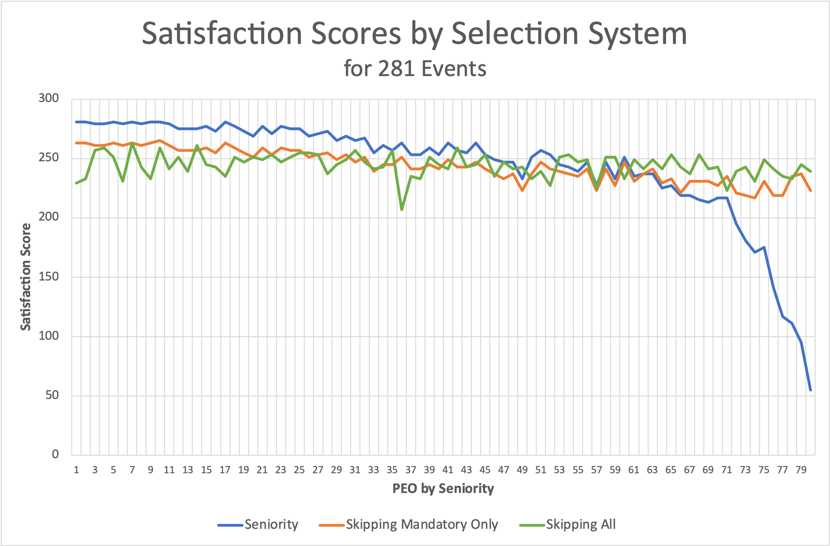

20%

10%

*The Seniority and Skipping Mandatory Only Systems converge due to volunteer volume.

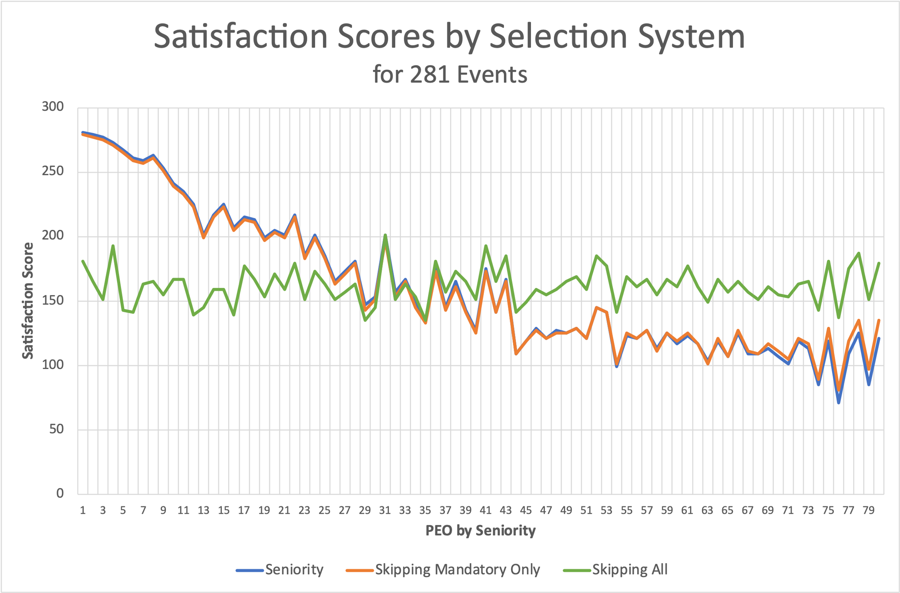

30%

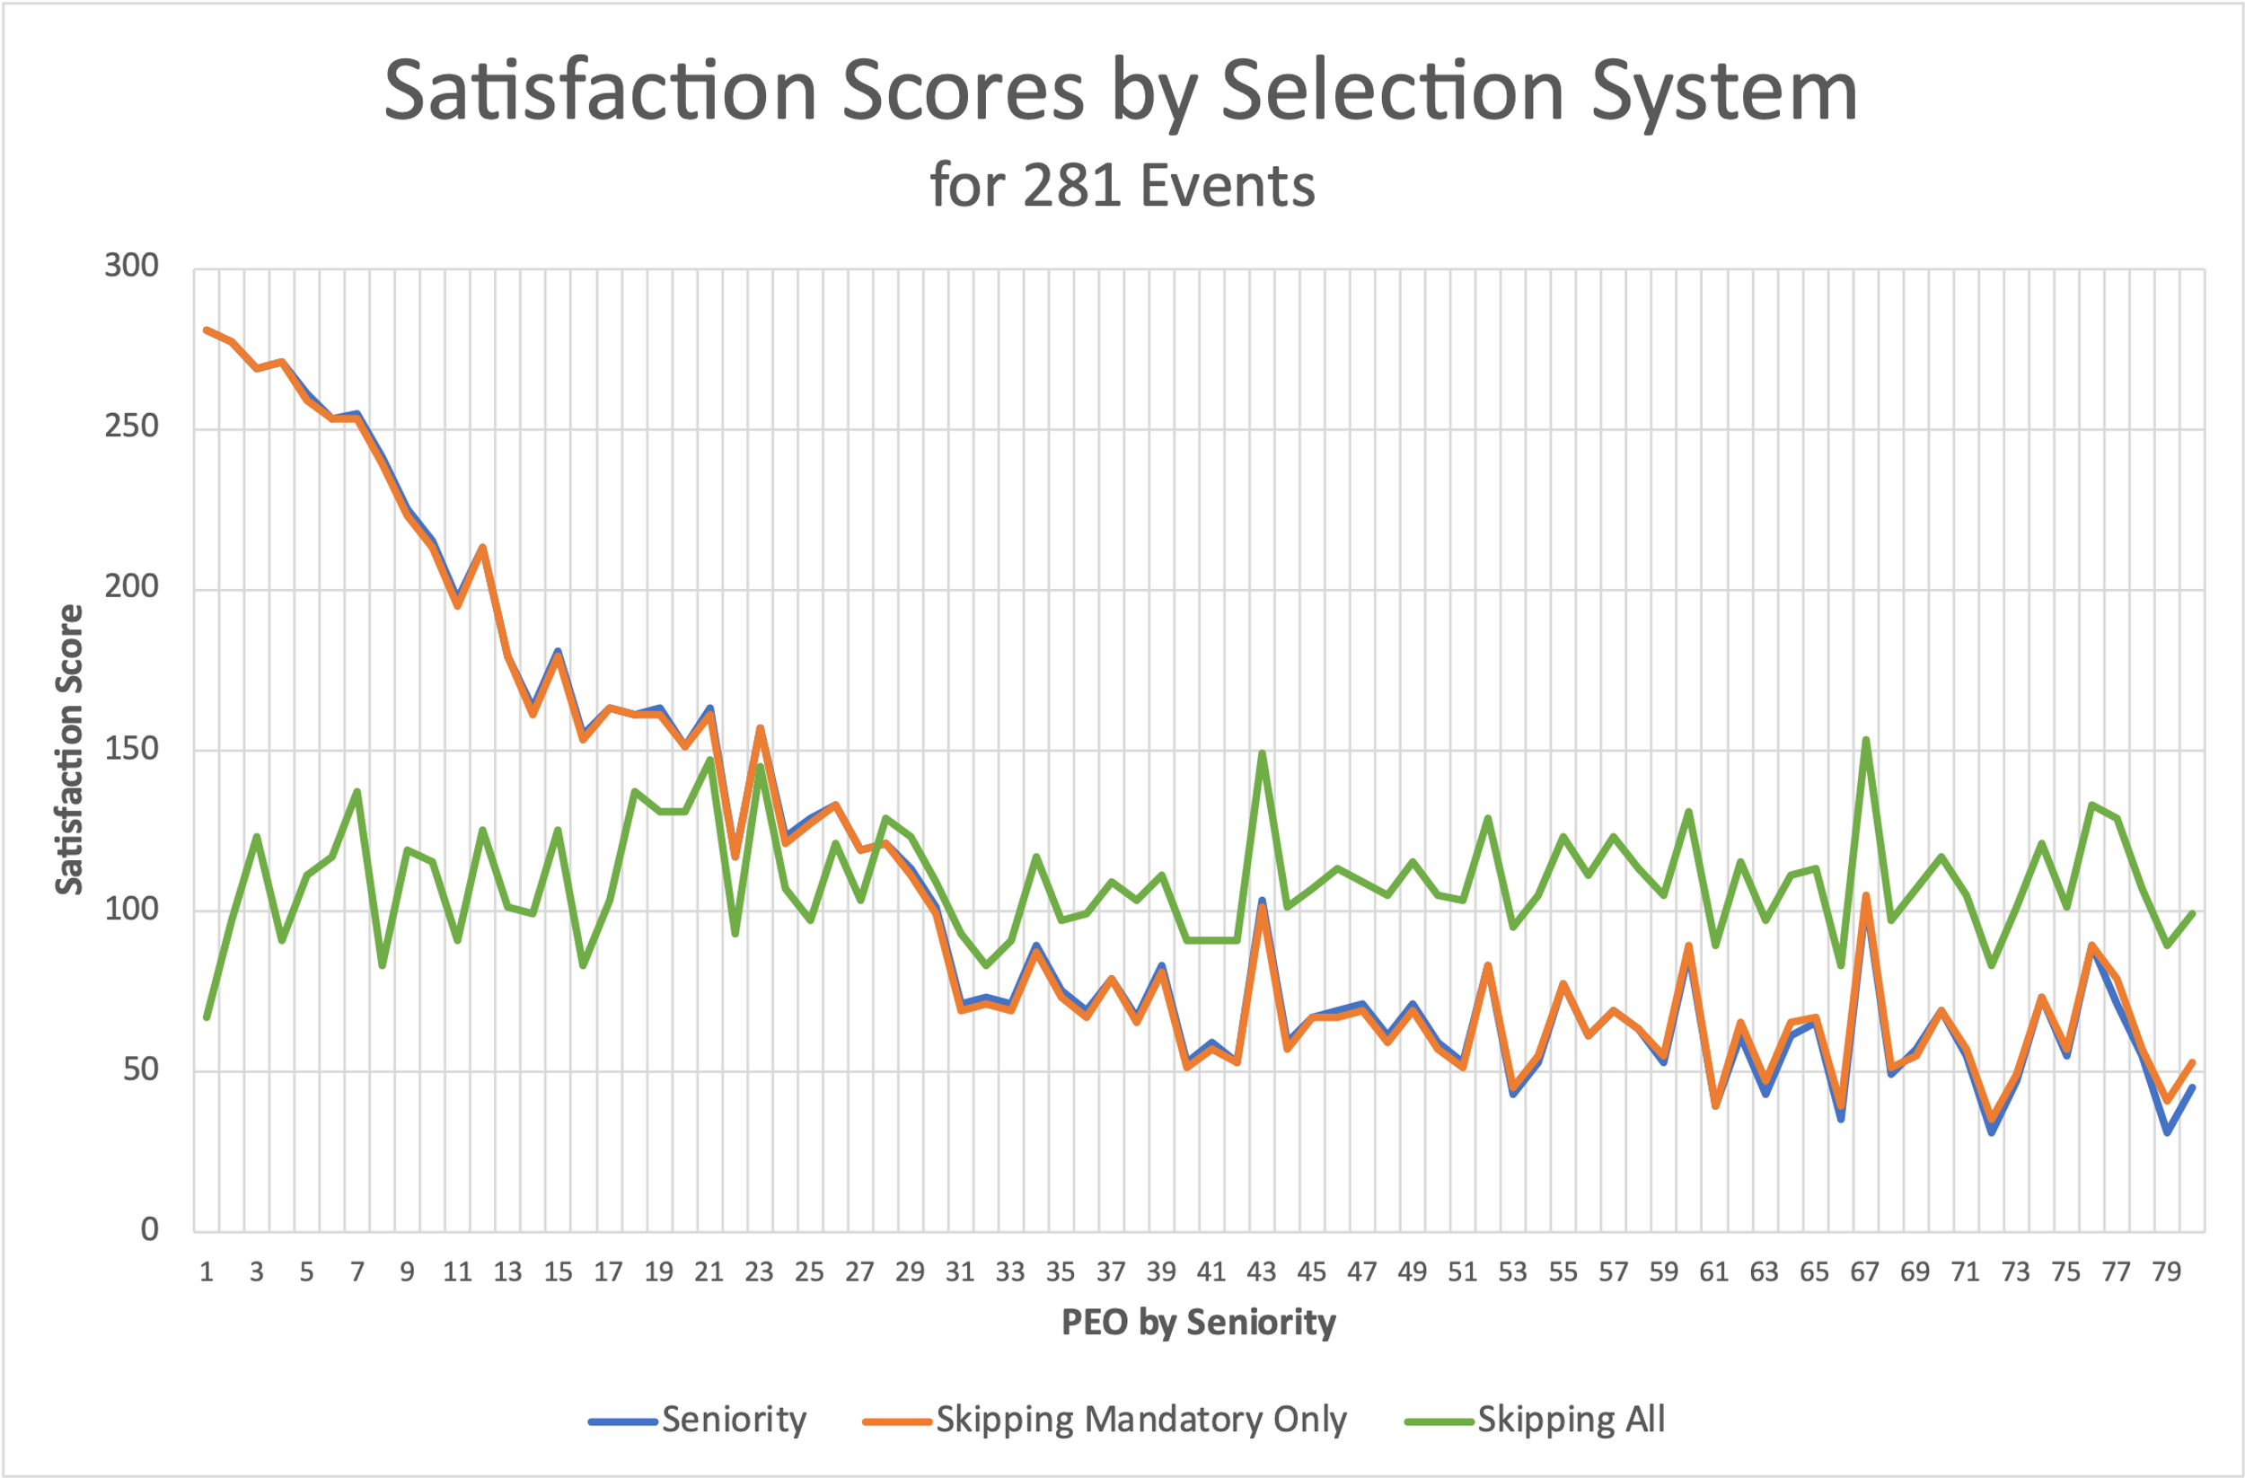

40%

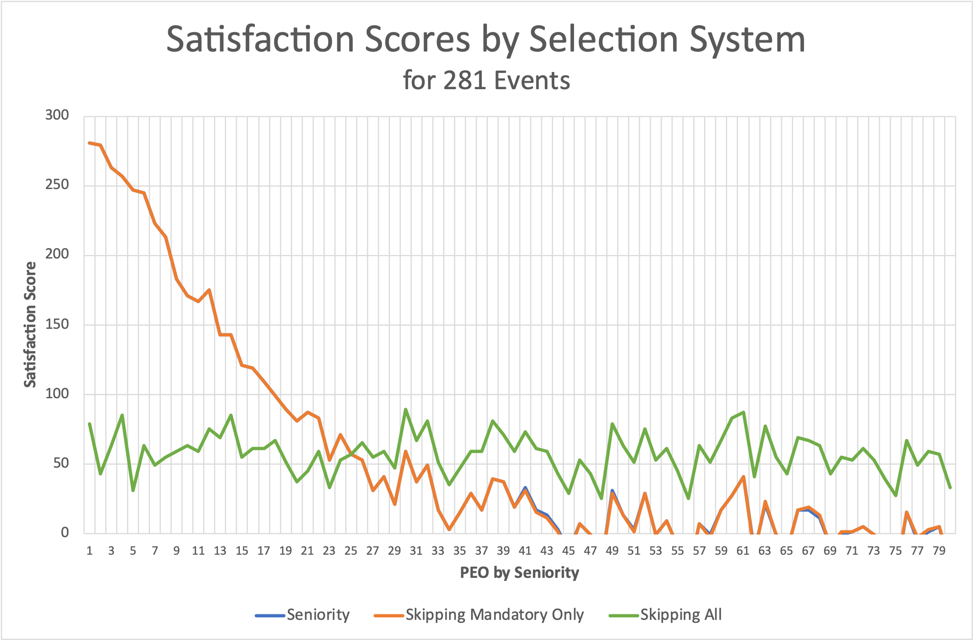

50%

Takeaways:

1. The more volunteers, the greater the spread of satisfaction scores higher up in seniority.
   * High seniority PEO’s scores stay relatively the same regardless of volunteer rate.
   * Mid to low seniority PEOs decline as volunteer rates rise.
2. The Seniority system is the least favorable system for low seniority PEOs.
3. The Skipping System satisfies PEOs much more evenly across seniority.
4. The Skipping Mandatory Only and Seniority Systems converge as the volunteer rates increase.

Events Worked Charts by **Volunteer** **Rate**: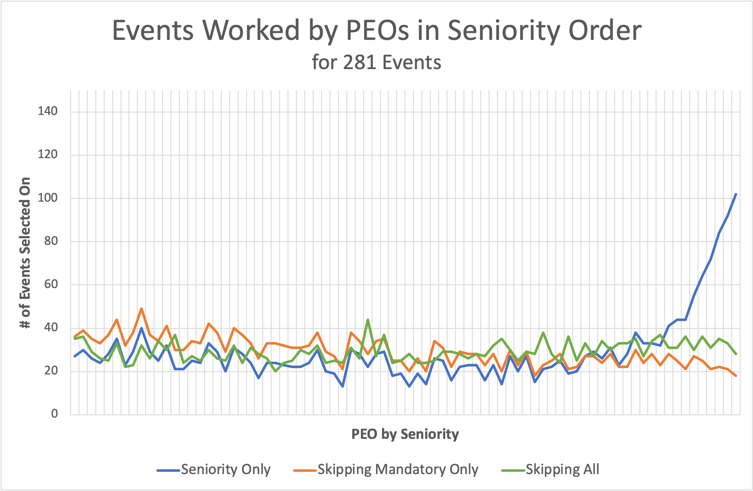

10%

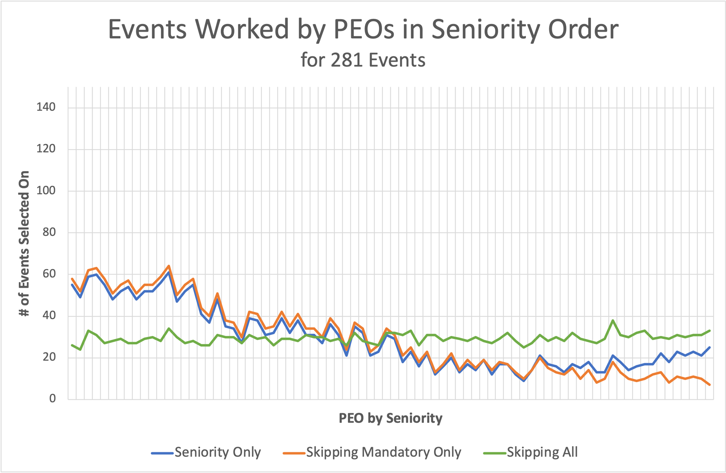

20%

*The Seniority and Skipping Mandatory Only Systems converge due to volunteer volume.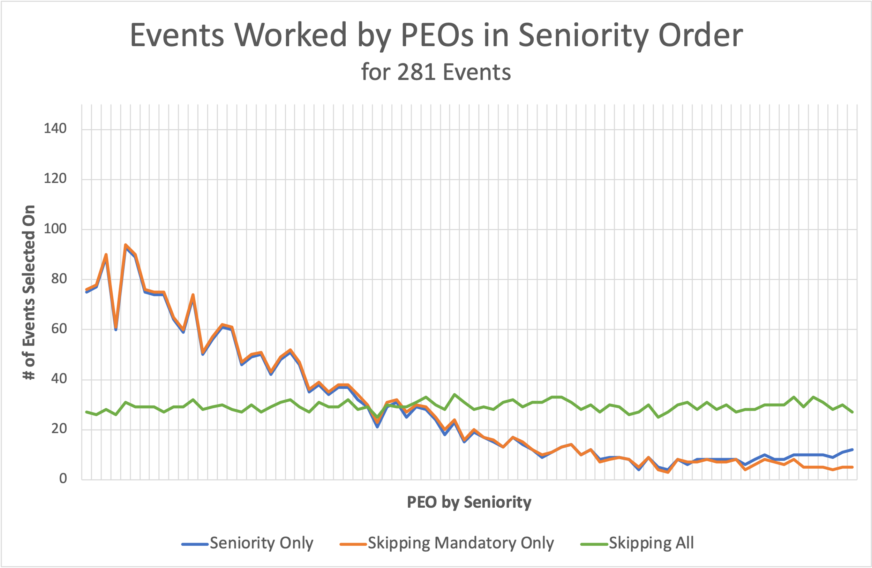

30%

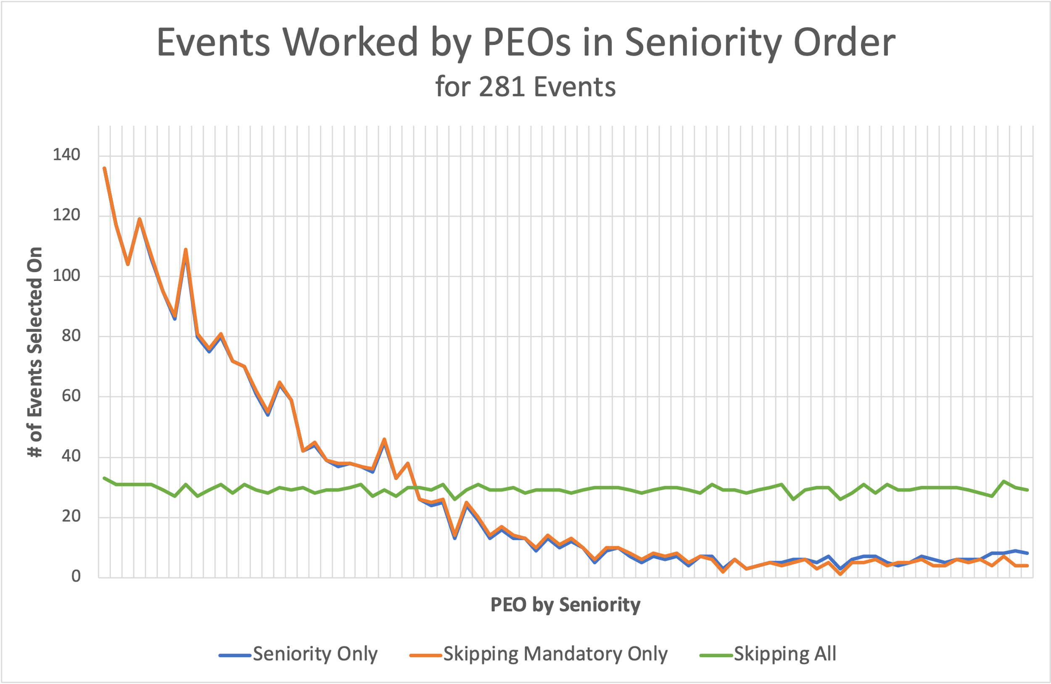

40%

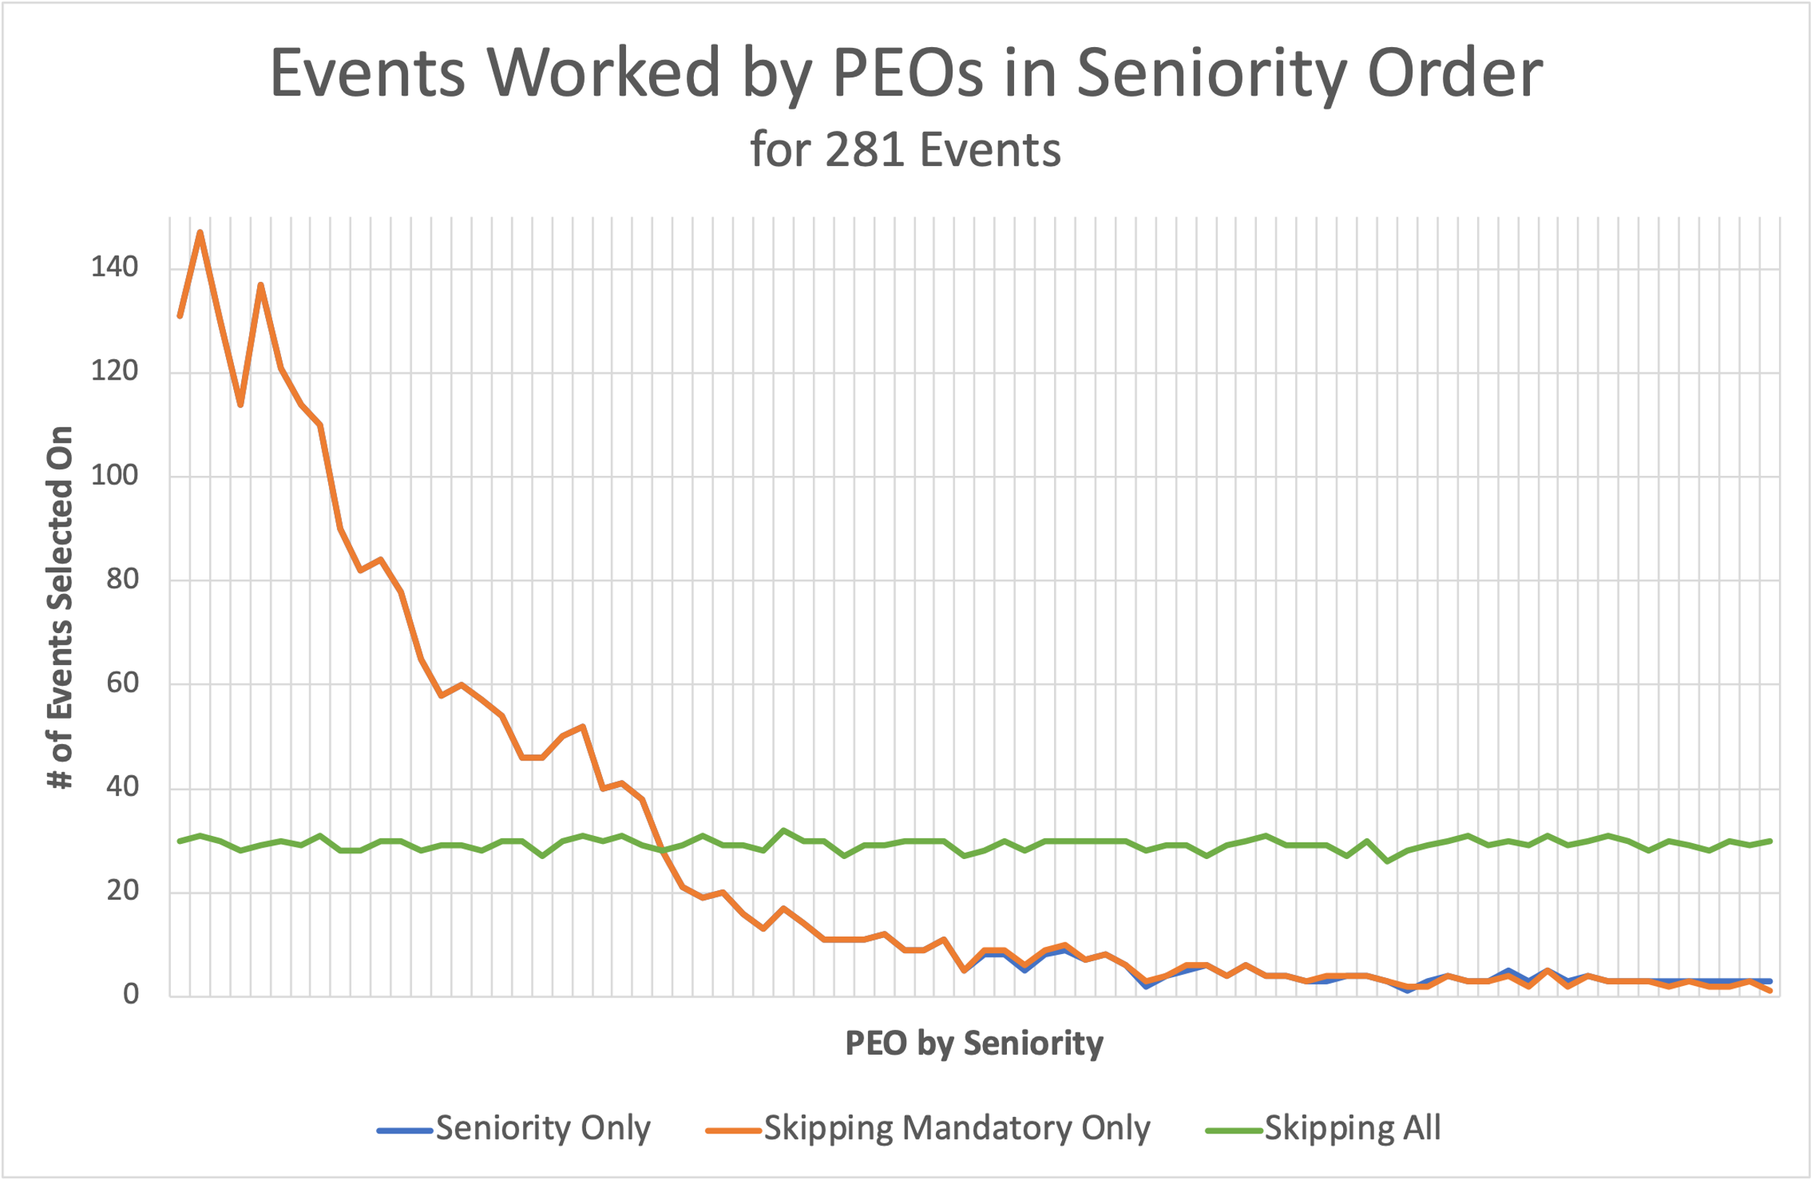

50%

Takeaways:

1. The Seniority system favored high seniority PEOs significantly more as the volunteer rate increased.
2. The Seniority and the Skipping Mandatory Only system became identical the higher the volunteer rate, favoring higher seniority PEOs.
   1. Quality of selection was more favorable for higher seniority PEOs. They got the OT they wanted and didn’t get the OT they didn’t want.
3. Volatility increased alongside volunteer rate.
4. Skipping All provided the most balanced event spread regardless of seniority or volunteer rate.

# Conclusion:

Seniority Selection System

|  |  |
| --- | --- |
| **PROs** | **CONs** |
| * Rewards Longevity * Easiest to implement. * Clear and easy to understand. * Verifying selection is easy | * Punishes new employees. * Easily exploited. |

Skipping Mandatory Only Selection System

|  |  |
| --- | --- |
| **PROs** | **CONs** |
| * Rewards Longevity | * Implementation requires more pieces. * More challenging to understand and verify |

Skipping All Selection System

|  |  |
| --- | --- |
| **PROs** | **CONs** |
| * Evenly distributes events. * Evenly distributes satisfaction scores. * Not Easily exploited. | * No reward for longevity * Implementation requires more pieces. * More challenging to understand |